K-Means

Overview on the Classical K-Means Algorithm
The k-means algorithm [3], [4] is an unsupervised learning algorithm that divides a dataset in clusters and it is one of the most used algorithms for data mining [19]. The k-means algorithm is able to process only numerical values, so if a dataset that contains non-numerical value needs to be processed, a convert operation needs to be performed to bring all dataset vectors (records) to the form of a d– dimensional set:
(1)
where the superscript T stands for matrix transposition and n is the number of database records.
The objective of k-means algorithm is represented by minimizing the intra-cluster variance by solving the optimization problem:
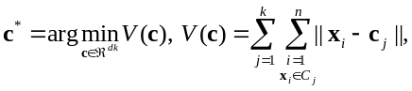 (2)
where: – the number of clusters 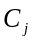, 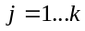,
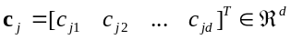 – the centroid of cluster ,
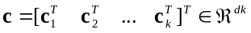 – the centroids vector,
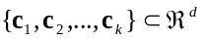 – the set of centroids,
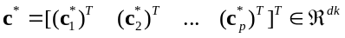 – the vector of optimal centroids and also the solution to the optimization problem (2).
The k-means algorithm uses a mathematical formula for calculating the distance 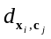 from every record and a centroid . If the Euclidian distance 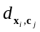 is considered:
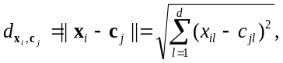 (3)
by replacing the distance formula in (2) with the formula for calculating the Euclidian distance, the optimization problem becomes:
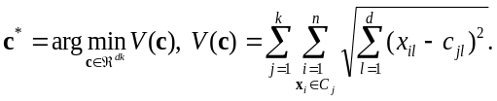 (4)
The formula included in (4) that is used for calculating the distance between every record and all centroids determines the shape of the final clusters.
The k-means algorithm consists of five major steps, 0 to 4, presented as follows. The step 0 is executed once, and the other ones are executed in an iterative (cyclic) manner until the final clusters are generated.
Step 0. This is an initialization step, where the number of clusters p, the initial centroids, the maximum number of iterations and the accepted error are chosen. This step is performed only once, before the clustering algorithm starts to iterate. The general notation will be used as follows for the current iteration, 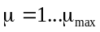, where 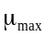 is the maximum number of iterations, which needs to be initialized. The initial value 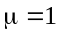 will be used.
There are several ways to initialize the centroids vector . This paper will use an initial centroids vector 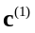 that contains the points where we believe that the final centroids will be. This approach is very flexible as it provides freedom on choosing and changing the initial vector and will generate different results for different initial centroids. This initial vector is:
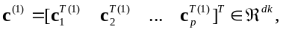 (5)
and it will initialize the set of initial centroids:
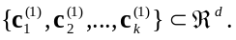 (6)
The accepted error needs to be initialized and it will be used as a stop condition in the algorithm.
Step 1. The distance between every vector and a centroid of cluster needs to be calculated using (3) for and 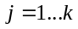.
Step 2. Based on the distances calculated in step 1, a new set of clusters can be generated. Each new cluster 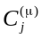 will contain the vectors 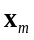 that are closer to its center, the centroid 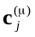. The cluster generation process is based on the distances that were computed in step 1. Each point has a number of k distances 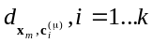 that were computed, the vector will be included into a centroid if the distance 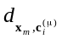is minimum, which means:
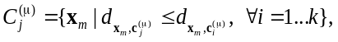 (7)
where every vector is assigned only to a single cluster .
Step 3. The new centroid 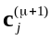 needs to be computed for each cluster based on the vectors that are assigned to the cluster . The new centroid is computed on the basis of the next formula that calculates the average of the coordinates for all vectors 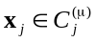:
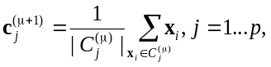 (8)
where 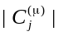 is the number of vectors assigned to cluster . Equation (8) generates the next centroids vector:
(9)
The scalar version of (8) is:
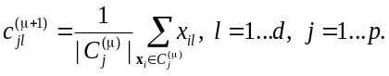 (10)
Step 4. The stop condition of the algorithm is checked:
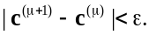 (11)
If the condition (11) is fulfilled, this means that the k-means algorithm had run in a cyclic manner until the centroids vector did not change between two consecutive cycles and the solution to the optimization problem (2) is the last obtained vector :
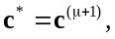 (12)
which corresponds to the final centroids:
(13)
If the condition (11) is not fulfilled, then an increment with of the current iteration index is performed, this means that will be replaced with 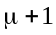 and the algorithm will continue with step 1.

